[28] November, 2025

Firm Reference: 25-194-00060

Transmitted Online

<<[Accountant Name]>>

Dear <<Salutation>> <<Accountant Surname>>
Re: [Name of Corporation] (the "Corporation")
We are solicitors for the Corporation.

We are in the process of preparing annual corporate resolutions for the Corporation for the financial year[s] ended [date] [to and including [date]].

Kindly confirm the following at your earliest convenience:
- That Corporation’s financial year-end is as stated;
- Whether any corporate actions or transactions during the relevant period(s) that would affect the content of the annual resolutions, including but not limited to:
  - dividends declared or paid,
  - redemptions, issuances, or transfers of shares,
  - changes to directors or officers,
  - changes to the Corporation’s registered office or minute book location;
- Whether any other matters or transactions for which corporate documentation may be required;

If there are any issues that require documentation or clarification, please advise so that we may assist the Corporation in maintaining an accurate minute book.

Should you have any questions, please do not hesitate to contact the undersigned.=
Yours truly,

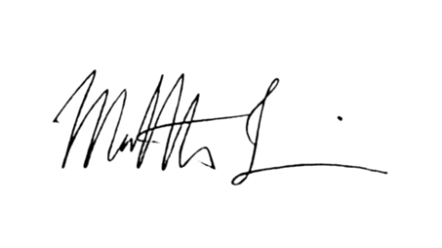
LEVINE LAW

Matthew AJ Levine

